Fox–Wright function

Def

Given vectors $$a$$ and $$A$$ whose size is $$p$$,and

$$b$$ and $$B$$ whose size is q.

The Wright Psi function is defined as follows.

$$WrightPsi\left(p;q;{\left[pair\left(a,A,t=1,t=p\right),pair\left(b,B,t=1,t=q\right)\right]}^{T};z\right)$$

= $$sigma\left(\frac{product\left(Gamma\left(a_{j}+A_{j}i\right),j=0,j=p\right)}{product\left(Gamma\left(B_{j}+B_{j}j\right),j=0,j=q\right)}⋅\frac{z^{i}}{i!},i=0,i=\inf{}\right)$$

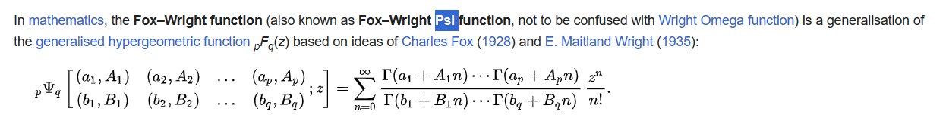

While, the normalized Wright Psi function is defined as follows.

$$Normalize\left(WrightPsi\left(p;q;{\left[pair\left(a,A,t=1,t=p\right),pair\left(b,B,t=1,t=q\right)\right]}^{T};z\right)\right)$$

$$\frac{1}{\frac{Gamma\left(a_{j},j=1,j=p\right)}{Gamma\left(a_{j},j=1,j=q\right)}}⋅sigma\left(\frac{product\left(Gamma\left(a_{j}+A_{j}i\right),j=0,j=p\right)}{product\left(Gamma\left(B_{j}+B_{j}j\right),j=0,j=q\right)}⋅\frac{z^{i}}{i!},i=0,i=\inf{}\right)$$

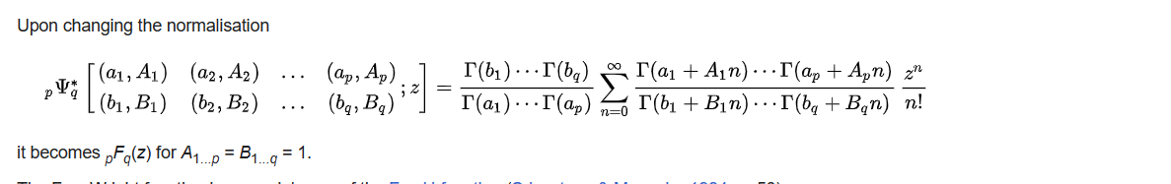

Intro

(non-normalized) Wright Psi function is a special case of Fox-H function depicted as follows.

For more details, see the Figure 2.2



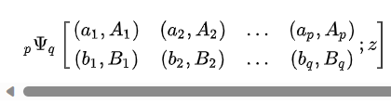

Figure 2.1

Source from Wiki.

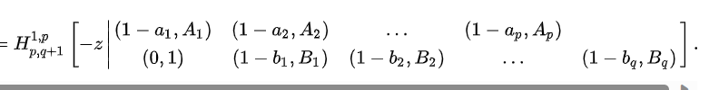

Figure 2.2

Source from Wiki.

Application

Modified half-normal distribution

It is used in defi

Modified half-normal distribution

Ref

[Fox–Wright function - Wikipedia](https://en.wikipedia.org/wiki/Fox%E2%80%93Wright_function)